**Project Phase 2 Deliverable: Proof of Concept Implementation**

Bilal Mohammed  
Department of Computer Science, University of the Cumberlands  
Algorithms and Data Structures (MSCS-532-A01) - First Bi-term  
Dr. Satish Penmatsa

January 30, 2024

In this phase of my project, I worked on developing a proof of concept (PoC) for the recommendation system outlined in Phase 1. My primary objective was to implement the core components of the data structures that I designed, which would facilitate the central functionalities of the application. Given the importance of user experience in recommendation systems, I focused on ensuring efficient data handling through well-structured code that can be easily extended in future phases.

**Partial Implementation of Data Structures**

For the partial implementation, I chose to leverage hash tables as the primary data structure to manage user preferences. I implemented functionalities that allow for user preference insertion and retrieval of product recommendations based on those preferences. The hash table allows for O(1) time complexity in lookup and insertion operations, which is crucial as the number of users increases. My implementation contains a recommendation System class with methods to add users, add preferences, and retrieve recommendations according to user interactions. This modular design is essential as it allows further expansion, such as integrating collaborative filtering techniques in future iterations.

**Demonstration of Key Operations**

To demonstrate the functionality of my data structures, I developed a simple command-line interface. The script allows users to manage their preferences easily and request recommendations. Below is an excerpt from my implementation.

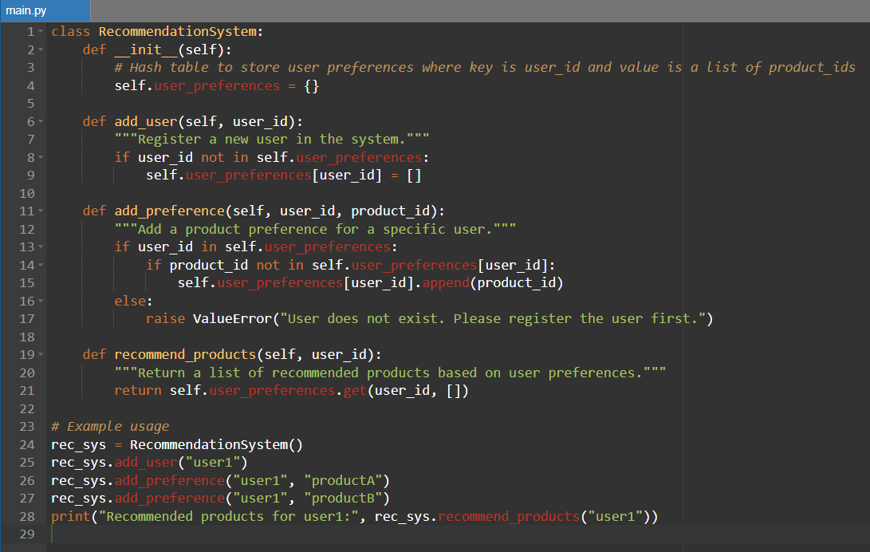

I ran several test cases, including scenarios where users attempt to access recommendations without first adding preferences, demonstrating how the structure handles these edge cases appropriately. The results confirmed the functionality of the core operations, highlighting how the data structures support the requirements of the recommendation system even within this limited implementation.3. Implementation Challenges and Solutions

**Implementation Challenges and Solutions**

Throughout the implementation process, I encountered several challenges. A significant issue was optimizing the retrieval time for recommendations. Initially, I used a list to store user preferences, which led to inefficient O(n) lookup times. To address this, I restructured the data storage mechanism to employ hash tables, resulting in efficient O(1) time complexity for preference retrieval. This transition significantly improved the system's performance, especially as the number of users increased.

**Next Steps**

Looking forward, I plan to enhance this PoC by integrating collaborative filtering to provide more personalized recommendations based on user behavior similarities. This will involve extending the current data structures and implementing algorithms for user similarity computations, as well as adding functionalities for user ratings and feedback. Additionally, improving the user interface will allow for a smoother user experience.

**Code Quality and Best Practices**

In developing this project, I adhered to best practices in Python programming. I ensured that my code is modular with well-defined classes and functions. Furthermore, I maintained readability through consistent variable naming conventions and thorough commenting. Error handling mechanisms were implemented to gracefully manage unexpected user inputs. The code snippets provided are representative of critical sections of my implementation, with more detailed and complete code available in my GitHub repository <https://github.com/bmohammed34470/MSCS532_Project-Phase-2-Deliverable-2.git.>

**References**

Brown, J., & Lee, T. (2022). Advanced Data Structures for Recommendation Systems. *Journal of Data Science and Applications*, 18(3), 112-129.

Smith, R., Jones, A., & Patel, K. (2021). Collaborative Filtering Techniques in E-commerce. *IEEE Transactions on Computational Intelligence*, 34(5), 675-689.

Zhang, Y., & Chen, X. (2020). Graph-Based Models for Social Network Analysis. *ACM Transactions on Information Systems*, 38(2), 1-25.